Kinematics Station Review
Station 1: Uniform versus Non-Uniform Motion
Uniform motion is motion at a constant velocity. This means both the ___________ and __________ of the motion is constant.
Non-uniform motion means the object is undergoing __________.
Either the ____________ and/or ___________ of motion is _____________.
Classify each of the following as uniform or non-uniform motion:
- A ball thrown up in the air: _____________
Reason:

- A shopper riding up an escalator at constant speed:________
Reason:

- A car slowing down as it approaches a stoplight: __________
Reason:

- A rider goes round a Ferris wheel at a constant speed: _____
Reason:

- A batter drives a homerun into the bleachers: _______
Reason:

Station 2:
Measured quantities with units and direction are referred to as_____________ quantities.
Measured quantities which do not consider direction are
referred to as ___________ quantities.
Identify each of the following as vector or scalar and use the correct symbol to represent the quantity described.
Symbols: $∆t, \vec{a}, ∆d, \vec{v}, v, \vec{d, } \vec{∆d}$
Quantities: distance, velocity, speed, displacement, position, time
Description | Vector/  Scalar? | Symbol? | Quantity Shown?
The puck was 20 m North of the blue line when the play ended.
The power play lasted 2.00 minutes
.
The player skated at 15 km/h.

The car braked at 3.0 km/h/s backwards.
The train travelled 150 km.

The plane travelled 500 km [NW].

The truck travelled at 50 km/h [East] on the 401 Highway.

Station 3: Distance versus Displacement
Starting from school, you walk 1.5 km East to Tim Horton’s for an IceCap. You then walk 0.5 km West to pick up your little brother at SunnyView Public School. You and your brother then walk 0.4 km East to your house.
Find your distance travelled. Find your resultant displacement.

Station 4: Acceleration
The kinematics of a jumping flea can be analyzed using high resolution video. In the first part of the motion, the flea uses its legs to “push off” the ground. This motion lasts
1.0 x 10 ⁻³ seconds. What is its acceleration if it reaches a velocity of 1.0 m/s [up] at the end of the push off?

Station 5: Displacement
During a 30.0 second booster phase, the velocity of a rocket changes from 200.0 m/s [ Up] to 500.0 m/s [ Up]. Assuming constant acceleration, determine the displacement of the rocket during this time interval.

Station 6: Final Velocity
As it approaches a construction zone, a car travelling at
17.0 m/s [ East] slows down at a rate of 1.5 m/s² [West] for 9.0 seconds. What is its final velocity at the end of the acceleration phase?

Station 7: Position- Time Graph Analysis
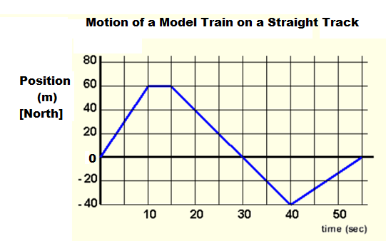
The position time graph for a model train moving back and forth on a straight track is shown below. Answer the following questions:

- What analysis technique do you use to find velocity? _______
- What is the instantaneous velocity at:
5.0 seconds? 12 seconds? 25 seconds?

- How would the average velocity over the interval from
15 to 40 seconds compare with the instantaneous velocity at 25 seconds? _________________________________

- Write a brief description of the train’s motion.

- Make a rough sketch the corresponding velocity time graph.

Station 8: Velocity- Time Graph Analysis
The motion of shuttle train moving in 1-D on a straight track is shown below. Note that this graph represents velocity!
Hint: Forward motion is above the x-axis (the + side)!
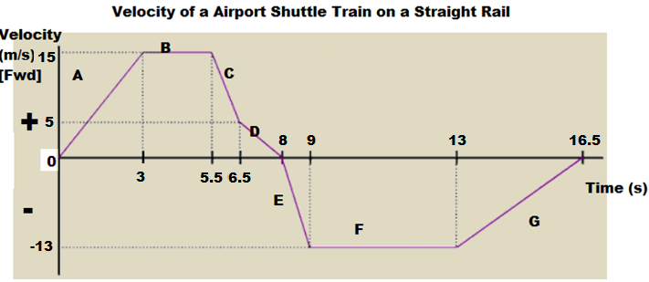
- In what interval(s) is the train going forward and speeding up? _____
- In what interval(s) is the train at rest? _________
- In what interval(s) is the train going forward and slowing down? ___
- In what interval (s) in the train going backward? _______
- In what interval(s) is the train going backward & speeding up? ____
- What analysis technique gives you acceleration? _________
What is acceleration of the train over the first 3.0 seconds?

- What analysis technique gives you displacement? _____________
What is the displacement after 5.5 seconds?

